

To:
Executive Vice-President Stéphane Séjourné
Director-General Kerstin Jorna

Cc: Ministers of the Competitiveness Council

Brussels, 16 September 2025
Subject: Securing the Future of Europe’s Solar Manufacturing Industry – Your Commitment at the Ministerial Meeting on 30 September 2025

Dear Commissioner Séjourné,
Dear Director-General Jorna,

On behalf of the European Solar Manufacturing Council and SolarPower Europe, we would like to invite you to use the upcoming meeting of Ministers and the European Solar PV Industry Alliance (ESIA) Annual Forum on 30 September 2025 to come with a concrete action plan for solar manufacturing in Europe. Your leadership and commitment are crucial as we collectively call for renewed political momentum to secure the future of Europe’s solar photovoltaic (PV) manufacturing industry.

A Strategic Moment for European Solar Manufacturing
The European PV sector is at a crossroads. Solar deployment is stalling, and our manufacturing base is under existential threat. The Net-Zero Industry Act is aimed to help Europe to produce at least 40% of its annual deployment needs for strategic net-zero technologies, and specifically 30 GW of solar PV manufactured in Europe. This cannot be achieved without additional, urgent and coordinated political support. We are seeing a wave of industrial closures and bankruptcies — a situation that must be addressed and turned around. At the same time, the measures need to ensure that the impact on electricity prices for final users, including energy intensive users whose global competitiveness is at stake, is moderate.
Status and Gaps in the European Solar PV Industry Alliance (ESIA)
The European Solar PV Industry Alliance (ESIA) was launched in 2022 by the European Commission with the aim to scale up to 30 GW of annual manufacturing capacity in Europe by the second half of the decade. It was designed to facilitate investment, de-risk re-industrialisation around clean technologies, and support Europe’s decarbonisation targets. However, despite tremendous engagement of the around 170 ESIA members, this ambition has not materialised.

A bold call for action: Turn law into reality
What is needed now is a clear political signal that the EU wants solar manufacturing in Europe to reach the goals stated in the Net Zero Industry Act. EU leaders should be ready to take action beyond the implementation of the Net-Zero Industry Act to secure strategic sovereignty in solar PV supply chains in line with its commitment in the 2024 EU Solar Charter.

We encourage you to use the Ministerial meeting and the ESIA Annual Forum to announce concrete next steps. We urge the Commission to consider:
- An action plan for European PV Industry 2030: A political commitment and roadmap to rebuild and grow the EU solar manufacturing capacities along the full value chain over time.
- Revise Public Procurement legislation
Beyond article 25 commitments in the Net Zero Industry Act, amendments under the revision of the Public Procurement Directive should reward resilience, EU content, and cybersecurity requirements. „Made in Europe“ shall be included in public procurement, creating the necessary demand to increase production capacities, while providing for a fair and open access to public procurement for all eligible suppliers.
- A new Cleantech Manufacturing Fund, under the next Multi-annual Financial Framework, with a dedicated facility for solar manufacturing. Such fund could channel various sources of support including grants, loans and de-risking instruments for industrialising clean tech, be it mature or innovative, and – crucially – cover capital and operational expenditures, in the shape of production-based support. It could be complemented with a mechanism that brings in national support through Auctions-as-a-service.
- Expand temporary OPEX support under CISAF to all segments of solar supply chain: Short-term support for operational expenditures are key to avoid further factory closures and retain talent at all stages of the solar value chain. This can be achieved by extending the CISAF framework chapter 6 to OPEX support for all segments of the solar supply chain.
- Increase European Investment Bank (EIB) funding and loan support. The EIB has so far played a minor role in financing solar manufacturing. Increased EIB involvement, such as offering zero-interest loans or counter-guarantees, could provide the financial stability and long-term confidence investors seek, as demonstrated in sectors like wind energy. The EIB should explicitly be regarded as a de-risking facility also for solar PV manufacturing investments. EIB should include “made in Europe” criteria in the projects they supports and offer low-interest loans to project developers which procure “Made in Europe” PV modules and inverters.

We encourage you to use the Ministerial meeting and the ESIA Forum to send a strong political message: Europe wants to preserve and rebuild its solar manufacturing industry – and is ready to do what is necessary.
Now is the moment to act decisively to save the remaining European solar industry – before it's too late. Implementation of the Net-Zero Industry Act is important, but insufficient on its own. With manufacturers in peril, there is no time to lose.

Yours sincerely,

[Signatures from CEO SolarPower Europe and Sec-Gen ESMC]

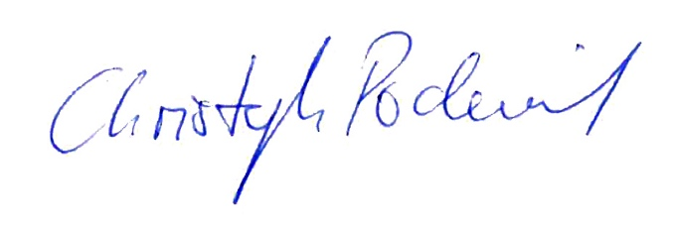
Christoph Podewils, Secretary General ESMC

https://www.reuters.com/markets/deals/swiss-solar-panel-maker-meyer-burger-files-insolvency-german-subsidiaries-2025-05-31/; https://www.solarbeglobal.com/norsun-shifts-fully-to-us-market-closes-european-factory; Solarwatt to close German solar module factory in August – pv magazine International

